**Laboratory Experiment on Kinematics**

**Introduction:**

Objects can be described by their location and at what time they are at that place. In physics, people often describe these elements by listing them out in a vector format where the components of the vector are the time and the position. An object can also be described with a velocity and acceleration in this way:

The velocity can also be expressed as the rate of change of position with respect to time. The acceleration is the rate of change of velocity with respect to time. When tracking the motion of an object, one would have a list of position vectors in chronological order:

. If one wants to obtain the velocities and the acceleration they would use the following calculation:

Using the same logic

Since these relations are recursive, one would have to know the initial values and . This is called discrete derivation because the time derivatives of the position and velocity are found using distinct datapoints. However, if one was given the accelerations A and want to find the velocities V and positions S, one would need to work backwards:

Using the same logic

Since these relations are recursive, one would have to know the initial values and . This is called discrete integration because the time antiderivative of the position and velocity are found using distinct datapoints.

**Objectives**:

The purpose of this experiment is to be able to obtain information about the velocity and position of an object based on information about its acceleration.

**Procedure:**

Part 1: Preparation and Calibration

1. On your smartphone, download “The PocketLab” app from the Appstore or Google Play.
2. Select “Use Internal Device Sensors”.
3. Place the device on a flat surface so that the positive x axis points right, the positive y axis points forwards and the positive z axis points upwards. It should remain in this orientation for the rest of this experiment.
4. 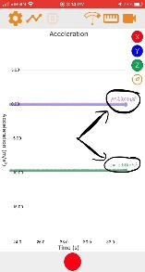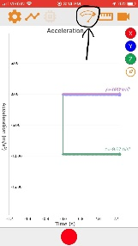Increase the sampling rate to its maximum.
5. While the device lies still on the surface, look at the graph for about 10 seconds. The X and Y values should be near and the Z acceleration should be near .

Part 2: Drawing

1. Mark a point on your surface, it will be called point A
2. Mark a point 15cm in the negative y direction from point A, this is point B.
3. 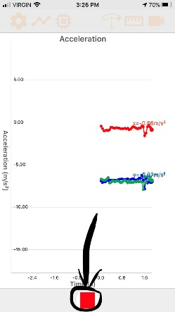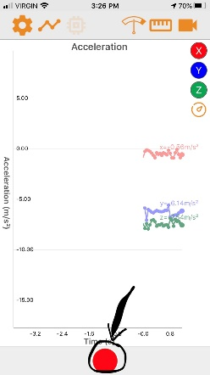Mark a point 15cm in the positive x direction from point B, this is point C.
4. Place the top left corner of the device at point A.
5. Tap the “record” button, move the phone’s corner on a straight path to point B, sharply stop, and press the “stop” button. The recording should be about 1 second in length or less.
6. 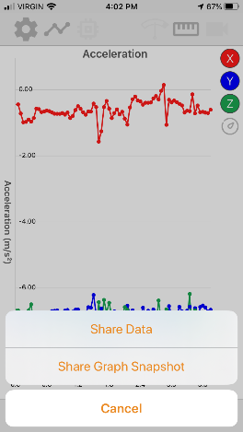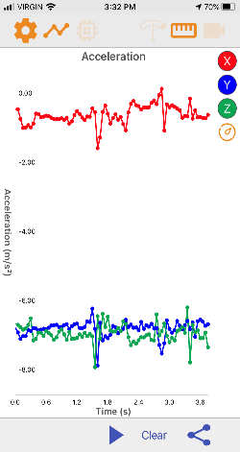Press the share button and then select share data. Use the method of your choice to share the acceleration data to your computer.
7. Open the data in excel and find the phone’s velocity and position for all times using the method discussed in the introduction, only consider the x and y directions. Make a scatter plot of the acceleration vs time data, and well as the position in Y vs the position in X.
8. Repeat steps 4-7 going on a straight path from point A to point B and then to point C
9. Repeat steps 4-7 going on a straight path from point A to point C.

**Analysis Questions:**

1. Why is it important to ensure that the phone does not rotate during the experiment?
2. Compare the shape in the scatter plots to the shape you drew. Provide some sources of error that might explain any discrepancies.
3. Determine the error of the scatter plot’s widths and heights when compared to the real shape.
4. At the end of each movement, the device seems to accelerate in the opposite direction of where it is moving. Discuss why this is.
5. On the acceleration graph of the “A to B to C” motion (Step 8), indicate for which times the phone moves vertically, and for which times it moves horizontally.
6. Observe the following acceleration vs time graphs. What words are being described? Support your answer by annotating the graphs and/or explaining in words.
   1. NO

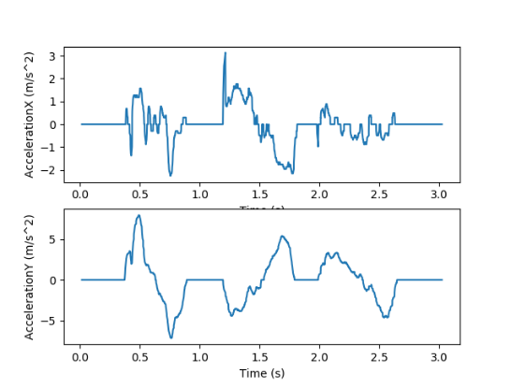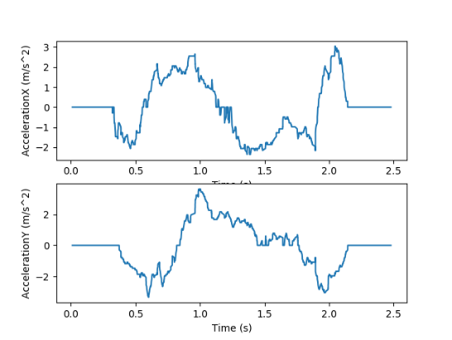

* 1. HALT

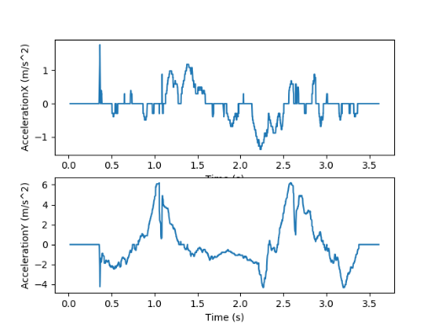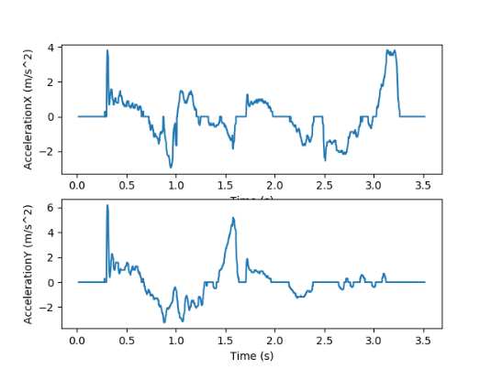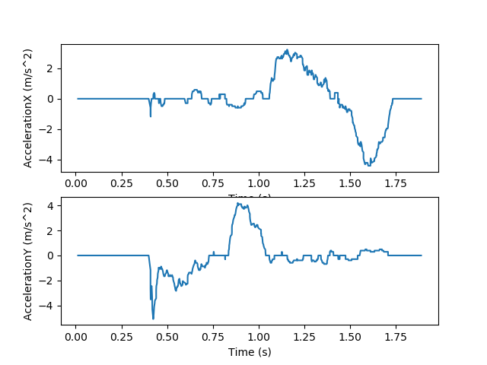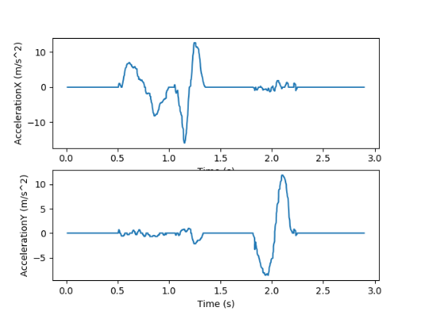

* 1. LOVE

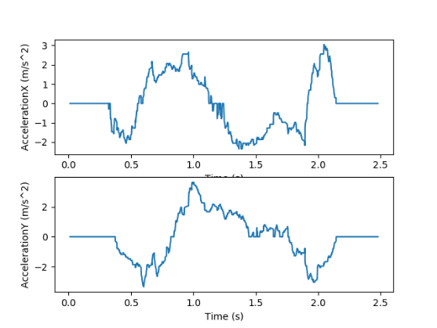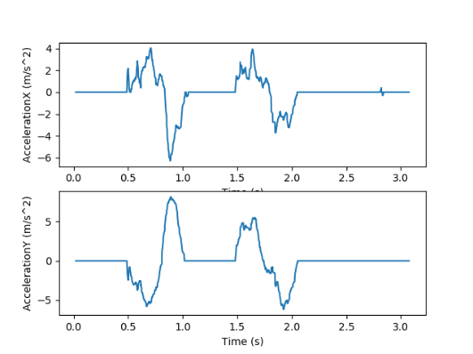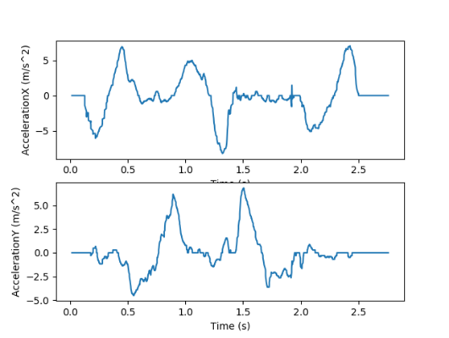

Example: The Letter “O”

